Why Not Complex Procedural Terrain?
Zhimin Zhao
1. Background
As is known to us all, generating procedural terrains of high-level complexity(including interesting features such as caves or overhangs) is a pretty parallel task. For this project, I would use CUDA to recreate a large, detailed polygonal mesh that represents the terrain as described in Chapter. 1 GPU Gems 3.
2. Main Procedure
(1) Marching Cubes and the Density Function
The terrain surface can be described by the density function d(x, y, z). If d>0, inside the solid terrain; d<0, in empty space; d=0, the surface of the terrain.
I. Generating Polygons Within a Cell
From each one we make a bit. If d<0, we set the bit to 0; if d>0, we set the bit to 1.
We then logically concatenate these 8 bits to produce a byte. If the case is 0 or 255, then the cell is entirely inside or outside the terrain and no polygons will be generated. Or else, it is used to index into various lookup tables to determine how many polygons to output. The vertex should be placed where the density value is approximately zero and thus we could get a triangle list output.

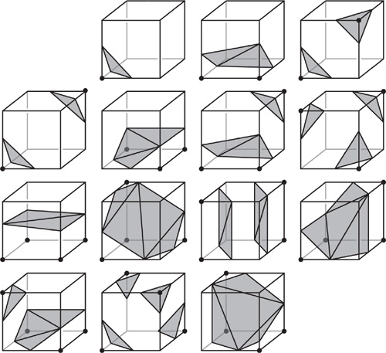
The 14 Fundamental Cases for Marching Cubes
II. Lookup Tables
There are two kinds of lookup tables here: one tells us how many polygons to create for the case number, the other demonstrates how to build up to five triangles within the cell
(2) Terrain Generation
For each frame, we sort all the vertex buffers from front to back. We then generate any new blocks that are needed, evicting the most distant block. Then we render the sorted blocks from front to back so that the GPU doesn't waste time shading pixels that might be occluded by other parts of the terrain. Blocks that don't produce polygons are put into a list so they won't be uselessly regenerated.
I. Generating the Polygons Within a Block of Terrain
First, we use the GPU's pixel shader unit to evaluate the density function at each cell corner within the block and store them in a 3D texture(an array of 2D textures). Then we visit each voxel and generate actual polygons within it.
II. Generating the Density Values
The PS that shades these triangles inputs a world-space coordinate and outputs a density value.
III. Making an Interesting Density Function
1.Initialize a flat surface
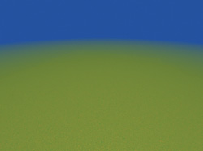
2.Warp the ground plane with a single octave of noise
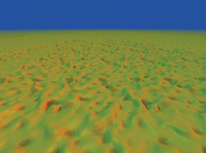
3.Modify the frequency & amplitude of the noise by scaling ws & the result of the lookup
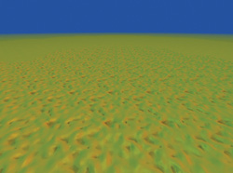
4.Add more octave noises
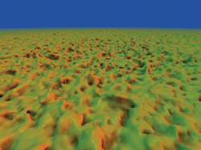
5.Add lower frequencies at higher amplitude(trilinear interpolation)
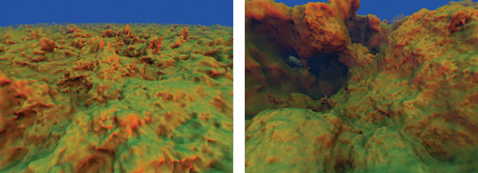
6.Warp the ws creates a surreal-looking terrain
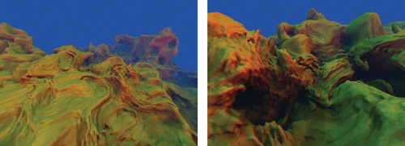
7.Make the adjustment by using either the pre-warp or the post-warp ws
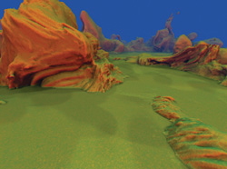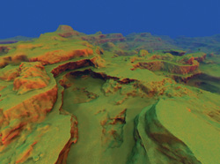
8.Customizing the Terrain
(1)Use a hand-painted 2d texture
(2)Add manually controlled influences
(3)Add miscellaneous effects
IV. Generate the polygons within a block of terrain
In the 1st render pass, we generate density values throughout a 3D texture.
For the 2nd render pass, we visit every voxel in the density volume and use the GS to generate & stream out to a vertex buffer anywhere from 0~15 vertices within each voxel. The vertices will be interpreted as a triangle list, so every 3 vertices make a triangle.
Data stored for each vertex: 1.world-space coordinate 2.world-space normal vector 3."ambient occlusion" lighting value(represents how much light is likely to reach the vertex based on the terrain).
Margin Data - During ray casting, instead of strictly interpreting each sample as black or white (hit or miss), we allow things to get “fuzzy”.
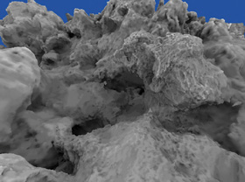
(3) Texturing and Shading
We use triplanar texturing, namely, three different planar projections, one along each of the three primary axes (x, y, and z). At any given point, we also use the projection that provides the least stretching at that point, with some projections blending based on the surface normal in the in-between areas.
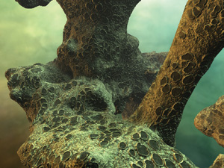
Another way to texture the terrain is by mapping certain height values to certain colors, creating striations. Allow the color scheme vary across the u axis in the texture, and let the v axis represent the altitude. When doing the lookup, use a low frequency octave of noise to drive the u coordinate, so that the color scheme alters as the viewer roams.
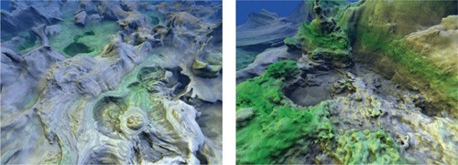
Texturing procedurally, a few octaves of noise can be used to perturb the normal vector, adding a few extra perceived detail.
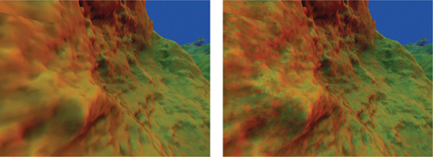
(4) Further Improvement
Utilizing Level of Detail, lower-LOD blocks simply represent a larger space.
Draw the low LOD first and slowly alpha-fade the higher-LOD block in/out.
3.Reference Material & Acknowledgement
http://http.developer.nvidia.com/GPUGems3/gpugems3_ch01.html

